

American International University- Bangladesh

Software Requirement Specifications

Project Title:

**Electronic devices Exchange, Specifications & Quality checking system. (QUALEX)**

Section: **D**

|  |  |
| --- | --- |
| Student Name | Student Id |
| Barua, Naresh | 19-40332-1 |
| Saha, Swarnab | 19-40398-1 |
| Kanta, Maria Akter | 19-40343-1 |
| Rahman, Md. Saqib | 19-40399-1 |

Introduction

Overview the 'Online Electronic devices Exchange, Specifications & Quality checking system (QUALEX)' services strive to provide solutions to develop and transfer easy and efficient way in the digital age and help reduce human pressure and time. QUALEX is a website or application written for all operating systems, designed to help users maintain and organize shop virtually.This program is simple to use for both experts and advanced users. It features a familiar and well-thought-out, attractive user interface, combined with strong searching Insertion and reporting capabilities.

**Objectives**

The main purpose of building this software are:

* To provide a unique user (customer) experience,
* To develop business relations,
* To reduce management costs,
* For boosting the efficiency of services,
* To provide quality online customer service.

An overview of the systems

**Description**

Our system is about online electronic devices selling, exchanging, specifications, & quality checking software. We can use this software through an application or a website. In our system, a user can perform some specific task like "viewing the content of our ***system portal***, can search for any product using the ***search bar***, can get any notifications over the application, can sell their devices in the ***SELL*** section, also can purchase any product from ***BUY*** section, can complete their transactions or billing method in our ***payment section*** & lastly they can give ratings or feedback in our ***Reviews*** area.

**Features**

The key features of this software will be:

* Automation Process.
* Search function.
* Central database.
* Integration Process.
* Analytics and Reporting.

**Use Case diagram:**

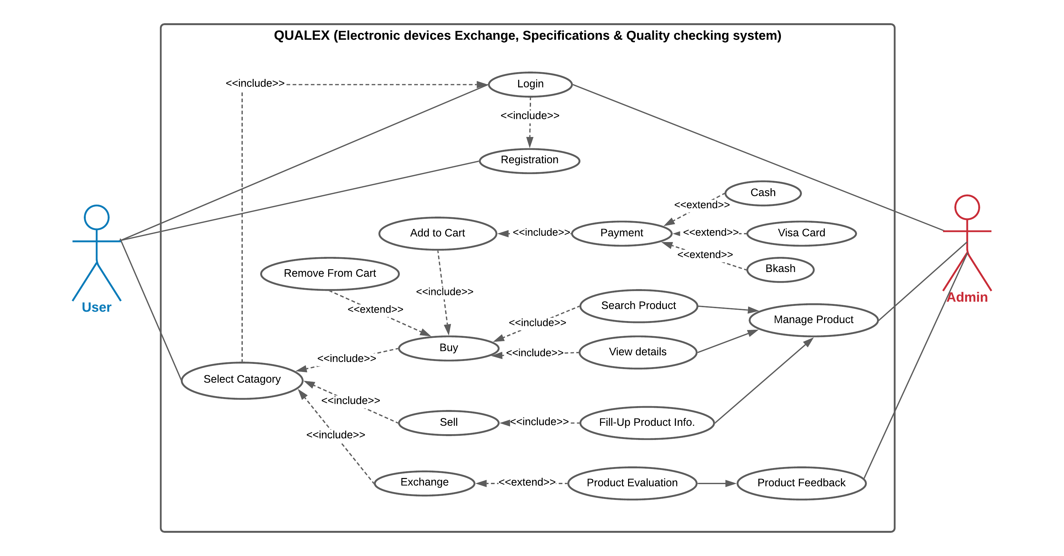

Justification

**QUALEX** is a software-as-a-Service (SaaS) that provides solutions through software and after the hardware is added. We use the 'Agile Model' method to build this software online. Still, there will be a tendency to create lots of issues after or before the development process of this system. Let's talk about the issues we'll have to deal with.

**Payment Issue**

**Communication Gap**

**Quality Testing Issue**

**Trust Issue**

These are some of the major issues we have to deal with. But *'while there is a will, there's a way*. If any problem arises, we can solve the problem by maintaining a time management process.

We also handle the budget estimation for our system's overall constraints. It is a necessary part of the project. management system. Lastly, we have to schedule the system to run all the modules efficiently, which leads to the solution of all the previously mentioned problems.

Stakeholders Analysis

1. **Stakeholders (Developing organization)**

**Identifying stakeholders:**

1. Admin
2. Board of directors
3. Investors
4. Project manager
5. Requirement Engineer
6. Team of coders, tester & designers
7. Freelancers
8. Customer
9. Vendors
10. Analysts
11. Marketing & Technical team

**Internal:**

As internal stakeholders for the system, we have a board of directors, investors, owner of the system, requirement engineer, project manager, and the team consists of coders, debuggers, designers. These are the people who have a direct connection with the system.

**External:**

External stakeholders are the people who do not have a direct relationship with the system. We hired external members like marketing, technical team, product analysts, and vendors to test our system.

**Marketing Team:**

The marketing team will help us to reach out about the software to know about us.

**Technical Team:**

The technical team will help us in an emergency if the system goes down and manage the customer support.

**Product Analyst:**

Analysts are those who know the product our system is based on. They have been working with the products for a long time, and know-how things work. They will test the devices and tell our customers about the device price, condition, and how much value customers can have if they want to sell or exchange their product.

**Vendors:**

Vendors are the people we will get the supplies we need during the whole system build. We will sell mobile, laptops, and other electronic gadgets in our system. We must ensure that the product they provide us should not have any issues because it can risk the company and other stakeholders.

1. **Stakeholders (Clients)**

**Internal**

**Secondary:**

Company or organization that is going to own the software.

**Primary:**

Admin, board of directors, investors, project manager, requirement engineer, employees, and customers will register and log in to the system.

**Admin:**

Admin will handle the whole system and help install, support, and maintain the server computer system.

**Board of directors:**

It is an elected group of individuals representing our stakeholders of the system. This committee will assess the overall direction and strategy of the system. It will take responsibility and manage the oversight policies.

**Project Manager:**

The project manager's responsibility is to maintain the system's quality being developed. Bring the individual personalities and train them. Maintain the communications among the team members and provide the members' vital resources.

**Requirement Engineer:**

Requirement engineer is a common role in system development. He will define, document the system progress, and maintain the requirements during the design process.

**Team of coders, testers, and designers:**

The system will be built by coders depending on the specifications. They will focus on higher priority features that customers will initially require to manage their businesses. The designers will make the system appealing to customers. A software designer is in charge of issue resolution and software solution planning. After determining the objective and parameters of the software, software developers will design or hire designers to create a solution plan. Software testers are in charge of ensuring the quality of software development and deployment. They are involved in automated and human testing to guarantee that the software developed by developers is fit for its purpose.

**Freelancers:**

Freelancers as a programmer who will work for us on an ad hoc basis, rather than as a full-time employee.

**Customers:**

Customers are our main primary stakeholders of the system. They can be direct users of the system and also cannot be. They can get both direct benefits and no benefits from the system. A customer is in charge of communicating project requirements and ensuring that all requirements are satisfied at the end of the project. Customers should be included in project planning at all phases, from the kick-off meeting until the project's completion. During customer talks, the client should also be in charge of identifying their demands.

Product vision and scopes

**Vision**

**QUALEX** combines e-commerce and re-commerce marketplace where customers can purchase anything by personalized orders and sell their unneeded/surplus products such as smartphones, laptops, and electronic accessories. QUALEX arranges personalized orders for customers. Hence, customers need not worry about buying high-end gadgets, etc. QUALEX works as a one-stop solution for its valuable customers, whether it is about buying, selling, or exchanging with whatever products they want.

QUALEX is a digital platform that lets customers experience secure, hassle-free buying, selling, or exchanging at the shortest possible time with special privileges. QUALEX offers a seller to sell unneeded items conveniently and accepts various payment methods either digitally or by cash. QUALEX's goal is to give endless options to consumers. When a consumer gets money by selling their unneeded kinds of stuff, it automatically increases their purchasing power at that moment.

**Scope**

Our system is a **User** (customer) - **System** interactive software. So we can call this method 'Ecosystem map,' which shows how the system interacts with each other and the nature of the relationship. So the scope we will represent in our project is called 'Ecosystem map.'

Add to Cart

Check Product

*Payment Gateway*

*Consultant*

*Purchasing System [BUY]*

requests

Billing history

Product Records

*Products Database*

*Customer Feedback*

**QUALEX**

**Electronic device ESQ system**

Product info

Electronic device

*Vendor*

*Selling System [SELL]*

Classes of the system

**Class diagram**

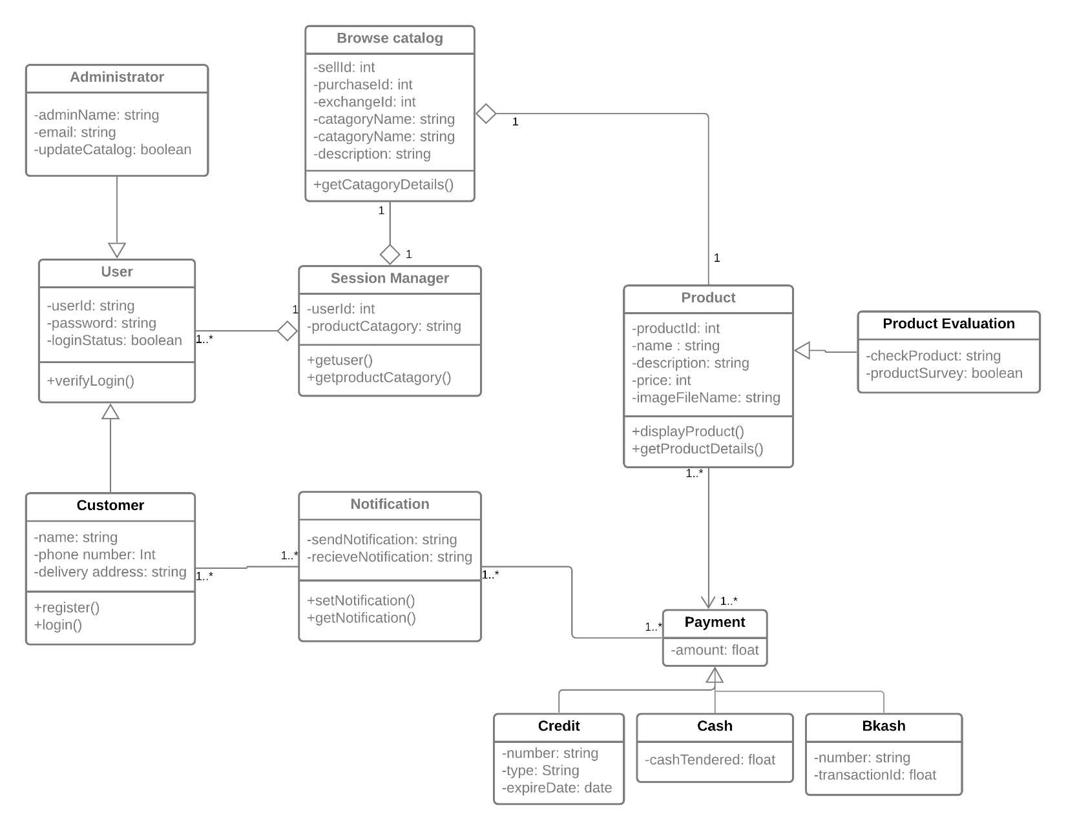

Modules of the system

**Let's get an idea about how the system will guide our users (Customers), which leads our software & its features, user-friendly:**

**LOGIN:** This login module is a portal module that allows users to get into the system.

**REGISTRATION:** This module will control the users' registration process. Any data management system's registration module is one of the most important. Because each implementation may have various requirements for information, it's critical to maintain the registration module flexible.

**SELL:** In this section, the user will get the categories to sell products such as (smartphones, laptops, tablets, television, smartwatch). After selecting a specific one, this (sell) will include the specification of the product. Then if the user wants to get the price or value of that product, this unit gives an initial value of that product & also provides the evaluation or quality of any products.

**BUY:** For purchasing any product, a user must visit this section, then they can view the details of any product; then they can add any product to the cart; then they can purchase the product by completing the payment method.

**Notification:** The system will notify users over the applications or the system browser in the notification section. A user will receive notifications about the offers, discounts, product details, purchase details, delivery details, and ads on different products.

**Feedback:** In the feedback channel, our customers can leave a comment about the system or review the system features, can share their thoughts about the

The usefulness of this system. And lastly, the user can rate the software.

**Payment method:** This section or method will not display in the content panel, but it is an important feature of our system. Because the user will complete their product purchasing process or billing process by using some specific payment method such as (bank, ATM transaction, VISA card, Bkash transaction, etc.), this process will show after the completion of the selling and purchasing unit.

**Search bar:** this section works for finding any product within the use of any section *(BUY, SELL).* It makes the system more flexible, and the user will search for any product they need without knowing the system's functionality.

Functional requirements of the system

|  |  |  |  |  |  |
| --- | --- | --- | --- | --- | --- |
| **Req ID** | **Date** | **Req Description** | **Dependencies** | **Originator** | **Testing Criteria** |
| **F01** | 01-11-2021 | The overall project will be service and online payment modules in the online system. | No dependencies. | Naresh Barua. | Identifying coding errors early and improving customer satisfaction by  providing the defect-free product. |
| **F02** | 03-11-2021 | Service- Following services are required: purchase, order, tracking, and seller information. | F01 | Md. Saqib Rahman. | Users interface, error exit testing and, confirmation of order testing. |
| **F03** | 04-11-2021 | Purchase- for purchasing following things are required: browse catalog, select product, make payment and place the order. | F02 | Swarnab Saha. | Checking the full form is working well or not. |
| **F04** | 08-11-2021 | Browse catalog- to view product information. | F03 | Maria Akter Kanta. | Checking the search bar performing accordingly. |
| **F05** | 12-11-2021 | Select product- to choose the required product. | F04 | Naresh Barua. | Checking the feature is working perfectly or not. |
| **F06** | 14-11-2021 | Place an order- to finalize the product. | F05 | Naresh Barua. | Check out the select method working accordingly. |
| **F07** | 20-11-2021 | Make payment- to pay the required amount to purchase the product. | F06 | Maria Akter Kanta. | Make sure the payment feature working well |
| **F08** | 22-11-2021 | Required data- users, should put on their data for selling and purchasing. | F02, F05, F06, F07 | Swarnab Saha. | Data handling logic and detailed information about the system's processes. |
| **F09** | 25-11-2021 | Report- the sell and purchase should be generated every 2 hours. | F02, F03, F08 | Md. Saqib Rahman. | Business Rules, Certification Requirements, Reporting Requirements, |
| **F10** | 30-11-2021 | Overlay – the system should support different overlay applications. | No dependencies. | Swarnab Saha. | External Interfaces, Historical Data management |
| **F11** | 02-12-2021 | Network- the system must have mobile and wireless network support. | No dependencies (other network device supports) | Md. Saqib Rahman. | Security assurance, network improvement, etc. |
| **F12** | 03-12-2021 | Payment mechanism- enable customers to make their payments. | F07, F08 | Maria Akter Kanta. | Transaction corrections, adjustments, and cancellations |
| **F13** | 05-12-2021 | Payment via credit card- customers can pay by credit card. | F12 | Md. Saqib Rahman. | We are making sure the payment process is working perfectly. |
| **F14** | 08-12-2021 | Payment authentication- validation criteria associated with method. | F13 | Naresh Barua. | Administrative functions, Authorization levels, Legal or Regulatory Requirements**.** |

Non-Functional requirements of the system

**Performance:** Performance requirements describe the background processes invisible to users, such as backup of our system.

**Scalability:** It assesses the highest workloads under which the system will still meet the performance requirements.

**Portability:** This usually includes hardware, software, or other usage platform specification**.**

**Compatibility:** This defines how the system can co-exist in the same environment**.**

**Reliability:** This quality attribute specifies how likely the system or its element would run without a failure for a given time under predefined conditions**.**

**Maintainability**: It demonstrates the time required for a solution or its component to be fixed, changed to increase performance or other qualities, or adapted to a changing environment.

**Availability:** It describes how likely the system is accessible for the user at a given point in time.

**Usability:** The quality of a user's experience when interacting with a product or system, including websites, software, devices, or software, is considered usability. Usability focuses on the user's effectiveness, efficiency, and overall satisfaction—subjective satisfaction: whether or not the user enjoys using the system.

**Security:** This non-functional requirement assures that all data inside the system or its part will be protected against malware attacks or unauthorized access**.**

**Localization:** This attribute defines how well the system or its element falls in line with the context of the local market-to-be.

System requirements of the system

**Operating system:** We can use this system in Windows and Mac. For windows, the windows version must be 10 or later, and for Mac, the version must be Sierra 10.12 or later.

**Processor:** For windows, the processor must be intel coreI7 or later, and Mac must be Intel**.**

**Memory:** Minimum memory required 2GB and 4GB recommended**.**

**Screen resolution:** 1920x1080 or larger

**Application window size:** 1920x1080 or larger

**Internet connection:** Required.

Manpower requirements of the system

Our software is business to business type project.

|  |  |  |  |
| --- | --- | --- | --- |
| **Software Project type** | **Coefficient**  **<Effort factor>** | **P**  **(Project Complexity)** | **T**  **(SLOC-dependent coefficient)** |
| Business to Business | 2.4 | 1.05 | 0.38 |

Here,

SLOC (Source lines of code) = 12000 SLOC/1000 = 12k SLOC

Now,

Effort =PM= Coefficient <Effort Factor> *(SLOC/1000) ^P

=2.4*(12) ^1.05

=**33**person

Development time = DM = 2.50* (PM) ^T

= 2.50* (33) ^0.38

= 9 months Required number of people = ST = PM/DM

= 33/9

= 3.6 members

=4 members

Budget estimation of the system

For a person,

Working hours per day = 6 hours Salary per month = 80,000 BDT

In a month working days = 20 days

So, working hours in a month = 20*6 = 120 hours

Now, Per hour salary in a month = 80000/120 = 670 BDT

In 9 months working hours= 120*9 = 1080 hours

For the project = 1080*670 = 7,23,600 = 7,25,000 BDT (approx.)

Requirement analysis = 20 days * 9 hours = 180 hours

Expense for requirement analysis = 180*500 = 90000 BDT

Expense for travel = 30000 BDT

Expense for office rent = 1,50,000 BDT

Expense for electricity & gas bill = 35000 BDT

Expense for training and hardware = 1,50,000 BDT

Total hours for 6-month maintenance= 6*18 = 108 hours

Expense for Maintenance = 108*1500 = 1,62,000 BDT

Total cost = 725000+90000+30000+150000+35000+150000+162000

=13,42,000

= 13,50,000 BDT(approx.)

Bill(+profit 20%) = Total cost + 20%

= 1350000 + 270000

= 16,20,000 BDT (approx.)

Constraints of the system

**Costs**: The reason for the high impact on the closed source is very clear. Every resource used in the closed-source has a cost, and if the project does not have a sufficient budget to cover the required resources, it will impact the project's performance. While in the open-source, since it depends on reusability and volunteers, the cost is considered very low, so the impact would be low.

**Scope**: In structured companies, it becomes very rigid and difficult to alter once the project's scope is defined. Failing to meet the scope means failure of the project. On the other hand, the Open source community members define the scope themselves, and there are no penalties to alter these scopes and affect the performance.

**Time**: The Closed-Source projects have definite timelines that have to be met. Depending on the time setup, the project manager will allocate resources and roles to the project. If the time is short, the project might not have sufficient resources to meet the time, affecting the performance. The OSS has flexible timelines so that the project can run at the desired pace.

Conclusion

In this paper, we tried to express the main factors for each project manager: constraints, risk management, some performance issues, and a technique that helps project managers schedule their projects. For sure that it's a very important and critical issue for all of the project managers to consider since these factors and processes that we discussed in this paper can save time, cost, and so many efforts. In the end, we believe that for anyone to be a professional project manager, an individual must be first a professional in setting and finding project constraints, risks, and set the project schedule correctly or has a technique that does that for them correctly and professionally. after that evaluating the performance of it.